**Executive Team:** Ryan Carpenter, Will Huber, Kyle Bailey, Kevin Nguyen



**INDEX**

**1.0 Executive Summary**

**1.1** Executive Statement

**1.2** Problem

**1.3** Solution

**1.4** Market

**1.5** Financial Highlights

**2.0 Mission**

**2.1** Mission Statement

**2.2** Explanation

**3.0 Vision**

**3.1** Vision Statement

**4.0 Opportunity**

**4.1** Problem Worth Solving

**4.2** Our Solution

**4.2.1** The App

**4.2.1a** Customer facing

**4.2.1b** Business facing

**4.2.2** WIBUR Process

**5.0 Market Analysis Summary**

**5.1** Market Segmentation

**5.2** Market Tendencies

**5.3** Competition

**5.4** S.W.O.T. Analysis

**5.5.2** The WIBUR Advantage

**6.0 Execution**

**6.1** Marketing Plan

**6.1.1** Social Media Plan

**6.1.2** Brochure/Handout Advertising

**6.1.3** Cold Calling

**6.2** Location and Facilities

**6.3** Software

**6.5** Key Metrics

**6.6** Target Marks

**7.0 Company and Management Summary**

**7.1** Organizational Structure

**7.2** Management Team

**7.3** Management Team Gaps

**7.4** Personnel Plan

**7.4.1** Exit Strategy

**8.0 Financial Plan**

**8.1** Revenue/Sales Forecast

**8.2** Expenses

**8.2.1** App Development and Maintenance

**8.2.2** Insurance Policy

**8.2.3** Advertising

**8.2.4** Legal Counsel

**8.3** Projected Profit and Loss

**8.4** Projected Cash Flow

**8.4.1** Business loan

**8.5** Projected Balance Sheet

**1.0 Executive Summary**

**1.1** *Executive Statement***:** WIBUR aims to create a cutting-edge app that connects homeowners and home exterior contractors. WIBUR is going to provide contractors with a platform to advertise On-Demand landscaping and snow removal services while creating a social network for scheduling services, marketing and reviewing services rendered.

**1.2** *Problem***:** The lawncare and snow removal industry is plagued with contract abuse on both sides of business. More often than not, contractual obligations leave consumers paying for unguaranteed services which are dependent on unpredictable weather or circumstances. Our team has discovered that the average household making over $50,000 combined income is more likely to pay for exterior upkeep services, yet consumer trends lean away from contractual obligations within the landscaping and snow removal industry

**1.3** *Solution***:** WIBUR is going to supply a network aiming to unit homeowners with landscaping and snow removal contractors in the form of a social media-oriented platform. WIBUR aims to not only engage the average homeowner but build a landscaping affiliation among creditable landscaping and snow removal businesses. This platform will offer the homeowner the option of purchasing either On-Demand lawncare and snow removal services (subject to surge rates) or provide a scheduling option for future services. We believe that the WIBUR social media platform will provide an avenue for business marketing expansion along with consumer reviews which will both spur user engagement. The convenience of a mobile app and eventual website will give WIBUR the ability to reach multi-generational homes with the purpose of becoming the household scheduling application for non-contract, On-Demand, landscaping and snow removal services.

**1.4** *Market***:** The WIBUR team has selected Monroe County to be our test subject. With nearly 588,150 (Adults), a majority of which falling between the ages 15-25 and 45-65, we believe that this geographic location will provide us with a niche market full of tech savvy homeowners that will be attracted to our zero-contract opportunity. Rochester New York currently has a median age of 38.6 between men and women. This only affirms our belief that this location can provide us with established tech literate clientele. Rochester, New York also provides a strong fluctuating climate. We have averaged that during a calendar year, Rochester will experience roughly 18 weeks of snow fall followed by roughly 34 weeks of spring/summer. This type of revolving climate will provide the perfect environment for WIBUR to help homeowners maintain the exterior presentation of their home year-round.

**1.5** *Financial Highlights***:** Through limited research we are able to determine that in 2017 the landscaping and gardening services industry recorded $88.6 billion in sales while maintaining an approx. 9.7% growth rate since 2015. We believe that our zero contract-on demand business format will be very appealing for householders of all generations.

**1.7** *Research***:** The team conducted primary and secondary research in order to completely understand how WIBUR can be an effective tool for consumers. The primary research conducted included interviews with multiple established lawn service businesses. The results after speaking with these businesses were favorable as they explained how if this system WIBUR is building were functional it would benefit them by expanding their client base. Also, we interviewed several homeowners. This was in order to gauge the interest levels of people in the target region. The home owners’ responses were positive as they like the idea of not being tied up into contract and possibly saving them money. The team also conducted secondary research. The team research statistics on homeowners in Monroe County. We looked at the average size of a person home and how much they were paying per service and aspects of our competition.

**2.0** *Mission*

**2.1** *Mission Statement***:** Our Mission is to connect homeowners with landscaping and snow removal professionals on a zero-contract basis.

**2.2** *Explanation***:** WILBUR's intends to set out and become a simple alternative for anyone whose responsibility it is to maintain any home exterior needs. Also, we express how simple it is to use our service through our basic, user friendly iOS platform.

**3.0** *Vision*

**3.1** *Vision Statement***:** We envision WIBUR being the household and go-to service provider for homeowner landscaping and snow removal needs. Mow by mow, plow by plow WIBUR aims to unite residential neighborhoods with reliable and professional exterior home service providers.

**4.0** *Opportunity*

**4.1** *Problem Worth Solving*: The landscaping and snow removal industry has moved towards the local small business revolving around a contractual agreement. The issue this has created is homeowners paying in the beginning of a season and having those services not rendered due to environmental circumstances. Another example of this issue would be homeowners paying weekly. If the lawn does not need maintenance or the driveway needs no plowing, you still need to pay because of contractual obligations. Market research has determined that the average snow plowing contract can be $200-$400 for a season.

For example, during a mild winter season a homeowner may only need 3-4 plows, yet due to a contract has paid $300 for plow services for the entire year. This results in the homeowner paying roughly $60 per plow which is far from cost efficient. This same example can be portrayed during the mowing season as well.

**4.2** *Our Solution***:** WIBUR will change the way home owners purchase their landscaping and snow removal needs. Through an app-based platform, we are going to attempt to connect with all generations through either services or employment opportunities.

**4.2.1.** *The App:* The WIBUR app will first be created and launched under the iOS technology aimed at providing a social media-oriented platform creating a connection between homeowners and WIBUR accredited, established or self-employed mowing/plowing crews in the Monroe County, New York area - willing to accept services requested. This app will be purchasable at the app store for a onetime .99¢, per account.

**4.2.1a** *Customer Facing:* Homeowner will be required to register accounts with the following:

* Name,
* Contact info (phone,email)
* Address,
* Reference,
* Front/back home/property pictures
  + Property info if system unable to geo-locate
* Preference
* Payment Information
* Liability Waiver
* Acceptance.

*Once finalizing the account*: Homeowners have the ability to customize their profiles, accept seasonal promotions/rewards received, * or directly seek the seasonal services offered by either a scheduled appointment or on-demand feature. WIBUR will charge a .25¢ service fee for on-demand services**.

*Once services are rendered:* Homeowners will receive job completion notification and a required project completion picture, immediately followed by a 5-star satisfaction survey and optional comments.

This on demand approach, similarly, used by Uber and Lyft, aims to eliminate the contractual trend and scramble the established market by providing a new approach to linking those in need with those who can help. We believe the winter season is where we will see this on demand approach really display its value to the average household consumer.

(*) Awards will be giving for different customer engagement i.e.:

Frequent Flyer (5-20% depending on # of purchases)

Rating 3 services (15%)

References (25% off 2 services for every 5 reference sign up & purchase)

(**) This service fee will be split as follows:*.15*¢ *WIBUR profits/.10*¢ *geolocation software expense*

**4.2.1b** *Business Facing:* Businesses or individuals interested in becoming WIBUR affiliated will have the beginning options of either registering by phone, by mail, or by online application similar, but more extensive than the homeowner application process. Business applications will be subject to a background investigation. Required business application information will include the following:

* Number of Crews registering ($10.00 fee per crew)
* Number of crew members
* Crew Members Full Names
* Crew Leader Registration
  + Name
  + Contact Info (phone, Email)
  + Picture
* Crew Ability
* WIBUR insurance purchase Y/N
* Required Proof of Insurance
* Background Investigation Authorization Y/N
* 3 Credible references

The WIBUR back office will aim to process and complete applications including background investigations within 10-12 business days. Application status notification will be sent to applicant via email and text provided.

*Once Operational:* Business and or crew will need to “go live,” alerting the WIBUR system that your crew is willing to accept On-Demand service requests. The WIBUR platform will provide badges based on performance and frequency of services performed, along with SURGE rate incentives for those available and willing during high frequency times. These incentive awards will vary based on performance rating and usage.

*Insurance needs to know*: WIBUR insurance will not cover WIBUR affiliated drivers during trolling OR transit to OR from a selected job.

*Job Completion:* Crew Leader MUST fill out brief job specific completion prompt. This will contain three requirements. 1) Job Completion Yes or No question

2) Comments / Issues? (Customer, yard, animals, etc.)

3) Picture requirement

Once these three requirements are completed, crew’s will be automatically placed back in an active, but trolling status, able to accept new jobs.

**4.2.2** *WIBUR Process:*

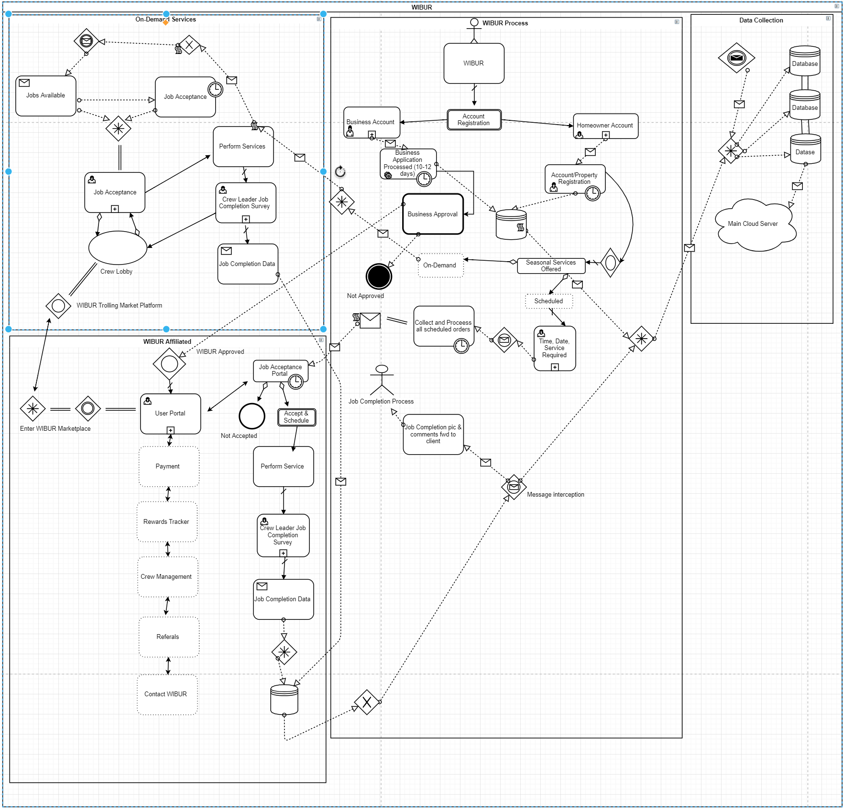

**5.0 *Market Analysis Summary***

**5.1** *Market Segmentation*

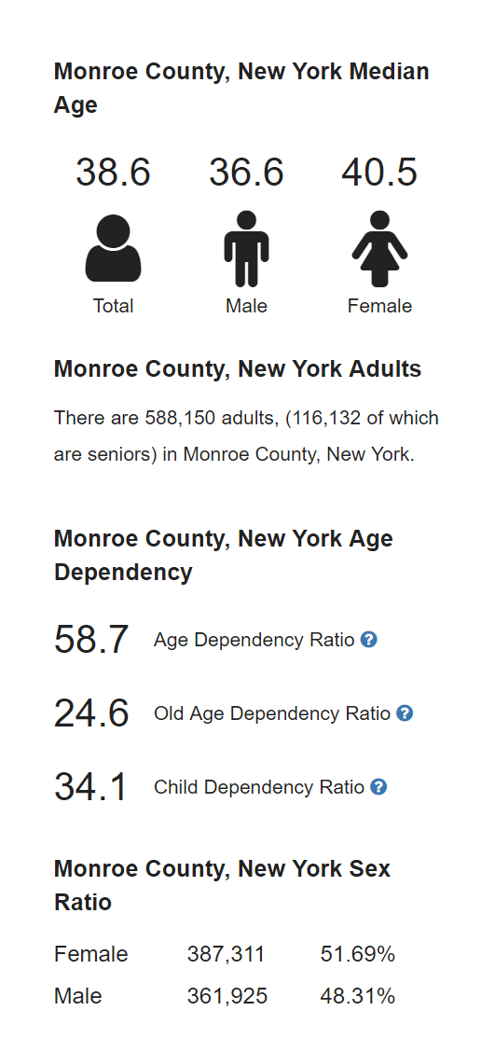

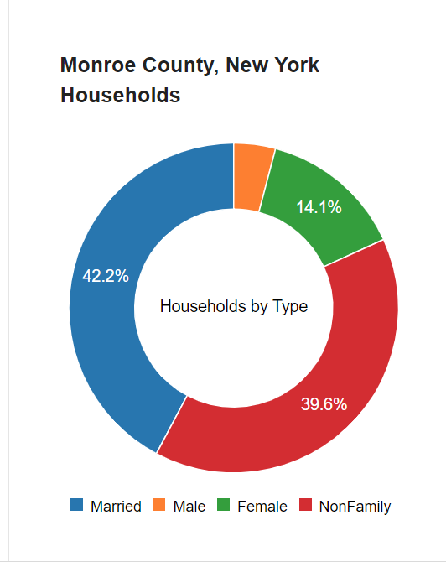

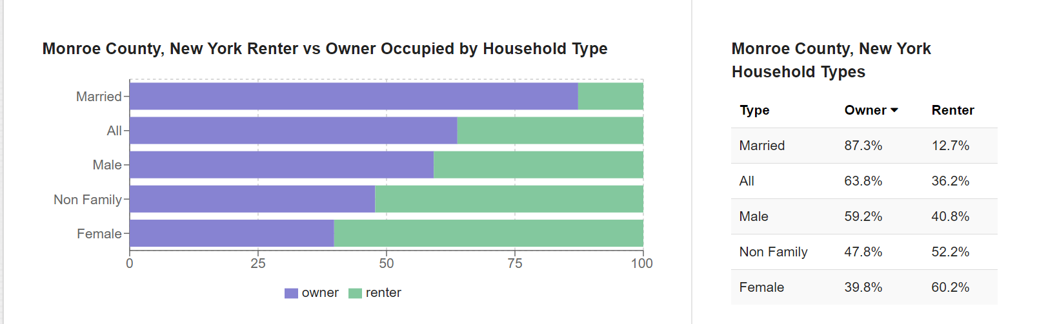

*Total Population by Country 2018*, 12 June 2018, worldpopulationreview.com/us-counties/ny/monroe-county-population/.

**5.2** *Market Tendencies*: 2017, The landscaping and gardening services industry recorded $88.6 billion in sales while maintaining an approx. 9.7% growth rate since 2015. While also finding a correlation between households with above-average disposable incomes are more likely to spend on landscaping services to improve the attractiveness of their homes. In 2017 the median household income was recorded at $61,372. Monroe County, our geographic launch area, holds a $53,568 median household income with a mean of $72,464 which falls directly in between the the market trend analysis conducted by the WIBUR team.

**5.3** *Competition*: Through preliminary research we have discovered two major business running under the same platform.

Plowz & Mowz:

* Founded: 301 East Seneca St., Manlius, NY 13104 12/2013
* Operating Across 30 major cities in the United States
* 12 complaints filed with the Better Business Bureau

SnoHub App:

* CEO: James Albis
* Founded in Westchester, New York
* Roughly 1,000 contractors and 2,000 customers registered
* Operating across Westchester and Fairfield County, Connecticut, Rochester, Albany, West Hartford, Providence, Rhode Island, and the Boston & Philadelphia areas.
* “The Uber of Snow Plows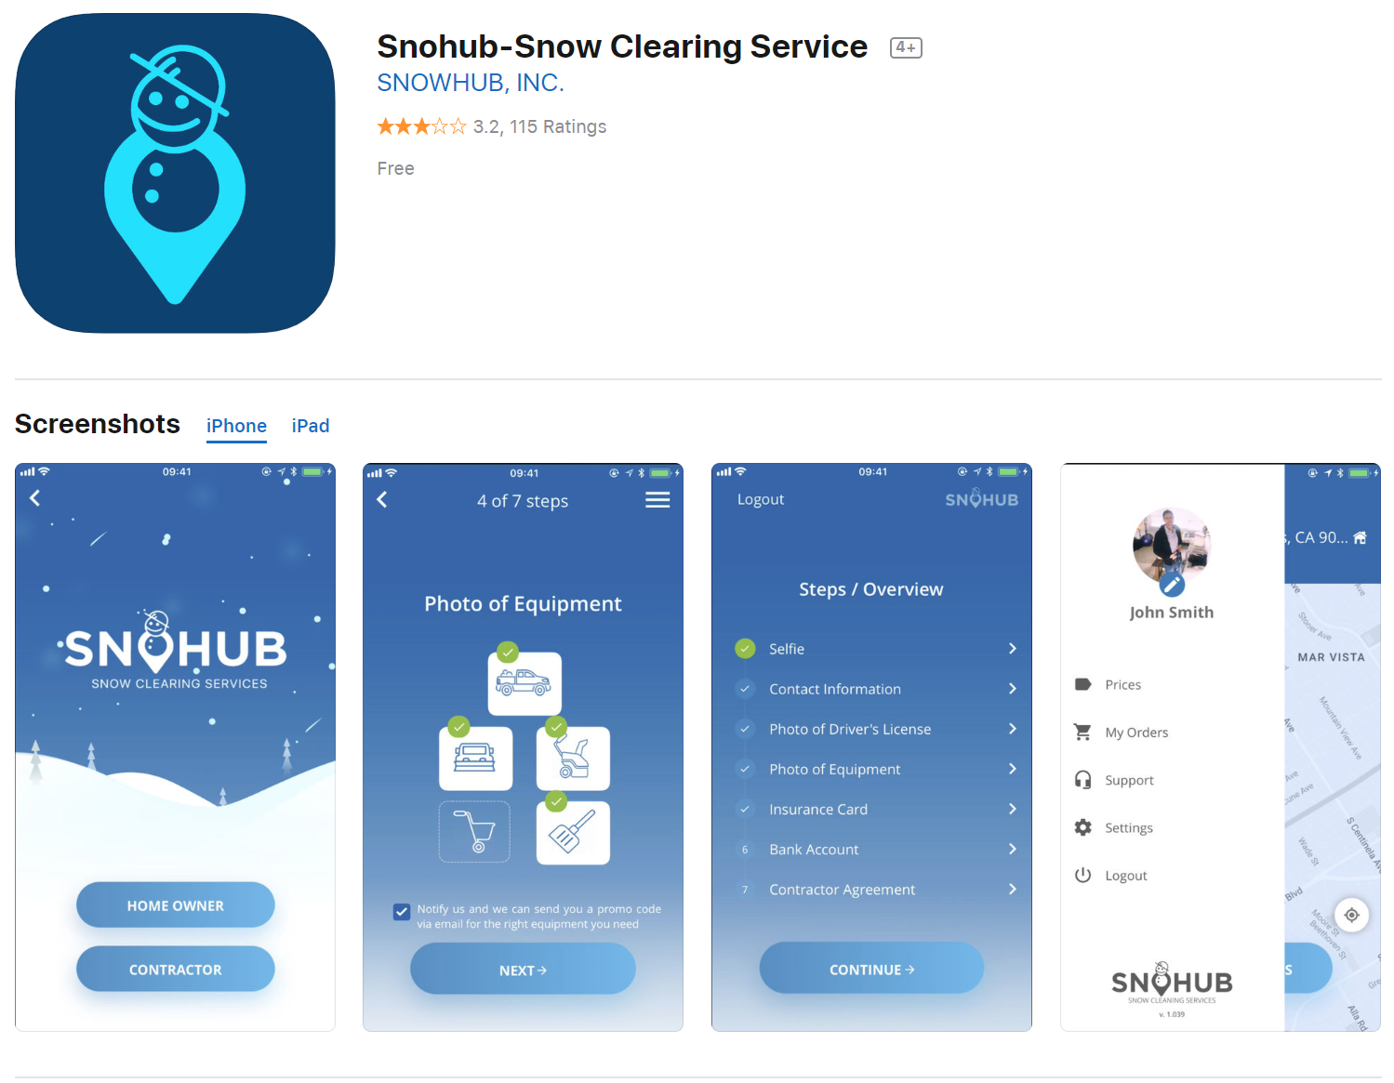

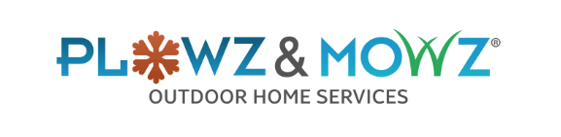

**5.4** *S.W.O.T. Analysis:*

**Strengths**

* Customer convenience by having the ability to select between On-Demand or Scheduled services.
* Allows platform for part time side workers (Highschool, College, Established lawn care businesses)
* Eliminates guaranteed contracts
* Low pricing compared to competition
* Lean startup cost and operational expenses
  + App development and initial advertising

**Weaknesses**

* Main connection to customers is through app engagement
  + Many older people aren't familiar with how to use app-based technology
* WIBUR users (workers) may not be as skilled as lawncare/plow care companies
* Must constantly maintain and upgrade app, making sure there are no issues
  + Leading to possible unexpected costs in the future

**Opportunities**

* Based on research, there are no companies like this in the area because current lawn care/plow providers connect with customers through phone, website, etc.
* Many customers looking for “in the moment” service can be directly targeted by our company.
* The field we are entering is critical in the Rochester area, as people are constantly looking for our services.

**Threats**

* Established local companies stealing users and by passing the app
* People staying with their current companies instead of switching over to use WIBUR.
* Without a non-competing agreement with service providers using WIBUR, there is the risk that customer use them directly, not through the app.

**5.5.2** *The WIBUR Advantage*: The advantage we hold over the competition is our strong marketing plan along with our competitive pricing. Although, our app will hold a signup fee for both businesses and regular consumers. Fortunately. we have discovered that our prices will be on average $2-5 cheaper than our competition, while still providing a stronger network of contractors ready and willing during SURGE rates.

**6.0 Execution**

**6.1** *Marketing Plan*

**6.1.1** *Social media plans***:** The following social media accounts will be held and controlled by the WIBUR executive team until we are offered the opportunity hire on staff. Platforms to include but not limited to Facebook, Google, Youtube, Instagram) - accounts controlled by WIBUR team.

* + Advertising will be primarily focused towards Facebook and Google recognition through post advertisement and short clip media. Advertising will begin with simple posts before progressing into Youtube and Facebook, commercial formatted advertising.
    - *Facebook:* Advertising will be set to 3x a week interval with a starting budget of $120 a month. This is subject to fluctuate depending on weather forecast and promotional advertising.
    - *Google:* Advertising will be basic due to potential Google advertisement cost. Google advertising will be a platform primarily focused around consumer review along with app recognition and review.
    - *Instagram:* Advertising will consist of a WIBUR business page that will aim to gain a strong following base through moderate engagement using regular posts of customer testimonials and short clips submitted direct messenger. This will be free advertising due to the WIBUR executive team managing the account.

**6.1.2** *Brochure/Handout Advertising:* Each WIBUR executive will be provided with 100 handout flyers each month. Each executive will be responsible for effective distribution of these flyers through neighborhoods and areas of high foot traffic. Distribution methods will be at the discretion of the holder.

**6.1.3***Cold Calling:*  Each WIBUR executive will be responsible for the documentation of 400 cold calls a week spread across the five working day schedule. Executives will also be responsible for the documentation of 10 recruitment site visits during the normal work week.

**6.2** *Location and Facilities:* During the beginning of WIBUR launch we will seek out either ORACLE or SAP data management processing software to manage the volume of intake data. Once the executive team has a better understanding of data management and products offered, we will make appropriate adaptations to follow our business process above.

**6.3** *Technology*

**6.3.1** *App Development:* WIBUR executive team will outsource our app development to a reputable freelance app developer. WIBUR will initially launch on the iOS platform as that seems to be the most cost effect method reaching the most clientele. The below graphic displays the average rates of app development. The WIBUR executive team anticipates a cost between $15,000 - $25,000 for app development and deployment. Along with an average $1,400 - $1,800 anticipated semiannual maintenance expense.

**6.3.2** *Software:* In order to launch WIBUR, we will need to develop two intercommunicating apps. The back-end of WIBUR will be a web-based app which will serve to hold and transfer data among the servers. This portion of development will take roughly 37 weeks and cost roughly $84,000. The front-end will be an iOS app. Through preliminary research the WIBUR executive team has selected the iOS platform due to its 75% market share against the competing Android platform. This portion of development will take roughly 35 weeks, costing $77,000. Total software development is estimated to take 72 weeks and cost $161,000.

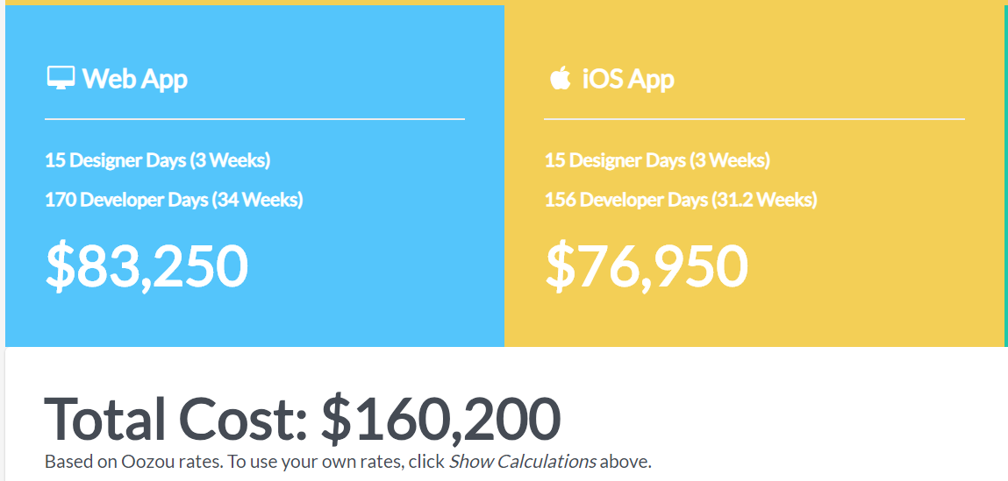

***6.5*** *Key Metrics:* As WIBUR plans to be the unifying link between homeowners and service providers, we will be splitting all earnings with the breakdown of every 65¢ for every $1.00 earned. The WIBUR executive team believes this base rate combined with incentives for high ratings and frequency of services provided will provide an appealing business opportunity for established companies to join and use the WIBUR affiliation as a marketing tool.

**6.6** *Target Marks:* The WIBUR executive team estimates that we will need to reach a rough total of 500 households. We have calculated that a season year in Monroe County averages 18 weeks of “snow plow” season, leaving 34 weeks of “mowing” season. During the snow season we can assume the average household will require plow services twice a week. Whereas during the mow season, the average household will only require a mow once a week. With a base rate of $27 per plow (excluding surge rates) and $32 per mow we estimate that WIBUR will need to achieve 200 successful plow services and 300 successful mowing services. If these numbers are achieved, WIBUR will succeed in a very strong launch. These numbers do not include landscaping misc. and shoveling profits. Full income statement available in section **8.0 Financial Plan**.

**7.0 Company and Management Summary**

**7.1** *Organizational Structure*: WIBUR will maintain an even organizational share among the four partners for the foreseeable future. This will also require that each member of the executive team is personally and legally responsible to their share of all financial obligations associated with WIBUR operations.

**7.2** *Management Team*: WIBUR executive team will be comprised of four members with the following responsibilities:

* Ryan Carpenter - Quality Assurance exec., Chief Financial Officer.
* Will Huber - Marketing and Sales exec.
* Kevin Nguyen - Cyber security management exec.
* Kyle Bailey - Operations exec.

**7.3** *Management Team Gaps*: Since the WIBUR team lacks skills and credentials in certain areas regarding our business we will have to seek out additional outside help. Collectively our team has no experience in app software development and will be forced to hire individuals outside our business to fulfill this service. Also, we will have to hire a team of lawyers in order to cover any legal responsibilities and duties WIBUR comes across.

**7.4** *Personnel Plan*: WIBUR executive team has agreed to withhold salaries for first three years of operations in hopes to recirculate earnings and grow the business. After the three years exec. members will have the option to recycle or earn salaries at a rate agreed upon among members.

***7.4.1*** *Exit Strategy*: WIBUR executives are given the option to withdraw at any time but will be held responsible for their agreed portion of any and all loans of financial obligations associated with WIBUR operations. It will not be until after three years, that buy out options will be made available to exec. members. If that moment is to arise - all delegation will be done with corporate attorney present.

**8.0 Financial Plan**

**8.1** *Revenue/Sales Forecast*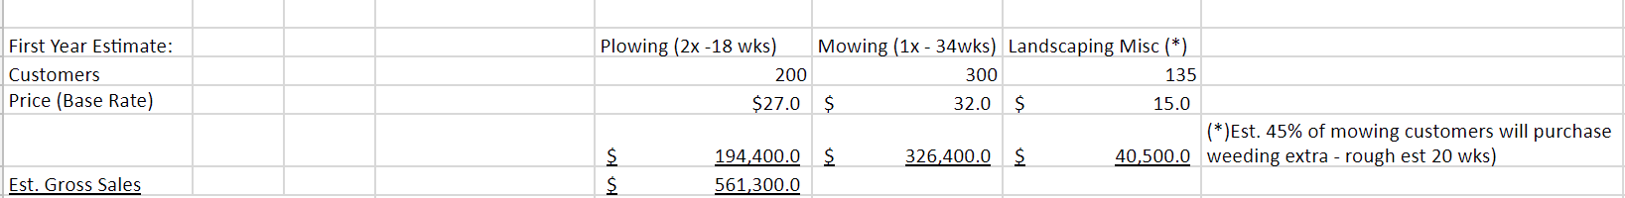

**8.2** *Expenses*

**8.2.1** *App Development, Deployment, and Maintenance:*As a team we have determined that hiring a freelance app developer will be the most efficient way to launch a well-rounded mobile app.

**8.2.2***Insurance Policy*:Due to the broad risk of an app based company providing a link to a zero contract, on demand landscaping service providers we will structure our insurance policy around a singular CGL policy with a $2,000,000 dollar total value broken up equally amongst four sub coverages listed below.

1. Commercial General Liability Insurance: $2,000,000
   1. Cyber Liability Insurance: $500,000
   2. Employee Practices: $500,000
   3. Errors and Omissions: $500,000
   4. Workers Compensation: $500,000

The average insurance premium for a policy of this size is $1400. We anticipate our cost to be close to $5,000 - $10,000 per year.

Provider insurance coverage options: Optional, $300 one-time subscription fee in order to buy into WIBUR optional insurance coverage. If providers do elect not to receive WIBUR coverage, they will be required to sign a waiver and provide proof of minimum $500,000 CGL insurance policy which will require yearly updating.

*Proof of insurance policy:*

* All service providers will have the ability to select email, text, or phone app notifications - These notifications will be used to notify providers on account requirements
* First renewal notification: 2 wks. prior to renewal
* Second notifications: Date of renewal
* Third Notification: 2 days after renewal date account will go into lock down.
* Termination: 2 weeks past renewal date.

**8.2.3** *Advertising:* Social Media: Accounts will be maintained by WIBUR exec. team.

* Platforms:*Facebook, Google, Youtube*
* Approx. yearly expense for advertising $5,000 - $10,000
* (75% Facebook advertising)

**8.2.4** *Legal Counsel:* Average retainer fee for a small business attorney is $250-$500 per hour or $1,000-$2,000 flat rate. We estimate and aim to keep this total cost around $5,000 for trademarking, start up, and app deployment for the first year, then a residual yearly expense of $500 is to be planned for. If during calendar year legal counsel is not necessary, money will be saved and circulated into savings, loan repayment, or advertising expenses.

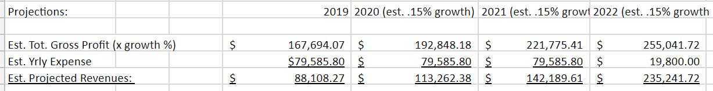**8.3** *Projected Profit and Loss*

**8.4** *Projected Cash Flow:* WIBUR will be partially funded on a personal bootstrapped commitment of $7,550 per all four parties involved. Each individual will determine their own way in producing their personal commitment.

**8.4.1** *Business Loan:* WIBUR executives will get a bank loan for $150,000 @ 12% for 36 months. This business loan will result in a yearly expense of $59,785.80 or $4,982.15 a month. Below is a graphic to verify loan information. 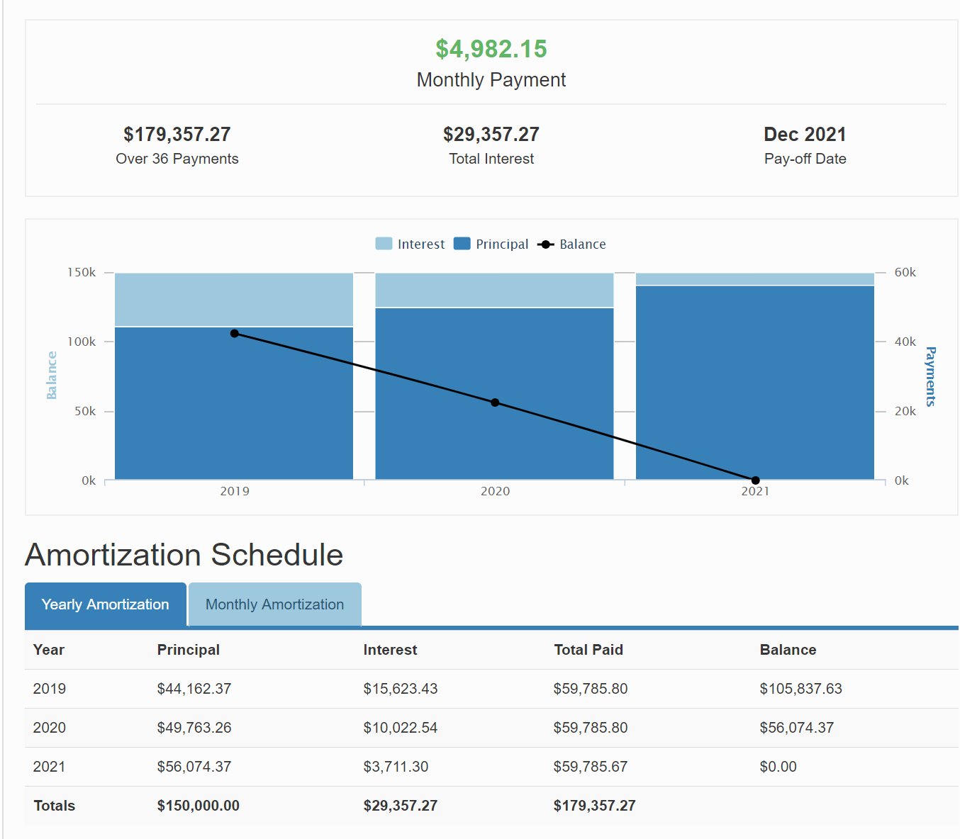

**8.5** *Projected Income Statement* 